DR. AMBEDKAR COLLEGE, DEEKSHA BHOOMI, NAGPUR
ANTI RAGGING CELL

Date: 16th September 2022
Name of the Programme: Anti- Ragging Awareness Program & Awareness
Programme on “Victims of Drug abuse: An eradication of Drug Menace”
Resource Persons: Hon’ble Shri Anilkumar Sharma
Adv. Smita Deshpande
Organised by: Legal Aid Clinic
Anti-ragging Cell
Name of Program Co-ordinators: 1. Dr. Pratima Lokhande
2. Dr. Sandhya Kalamdhad
Name of Members : 1. Dr. Priti Singh
2. Ms. Shilpa Rathod
3. Mrs. Vaishali Sukhdeve
4. Ms. Sarika Kamdi
Number of Attendees: Around 223
Name of Venue: College Auditorium Dr. Ambedkar College Deeksha Bhoomi, Nagpur
NOTICE
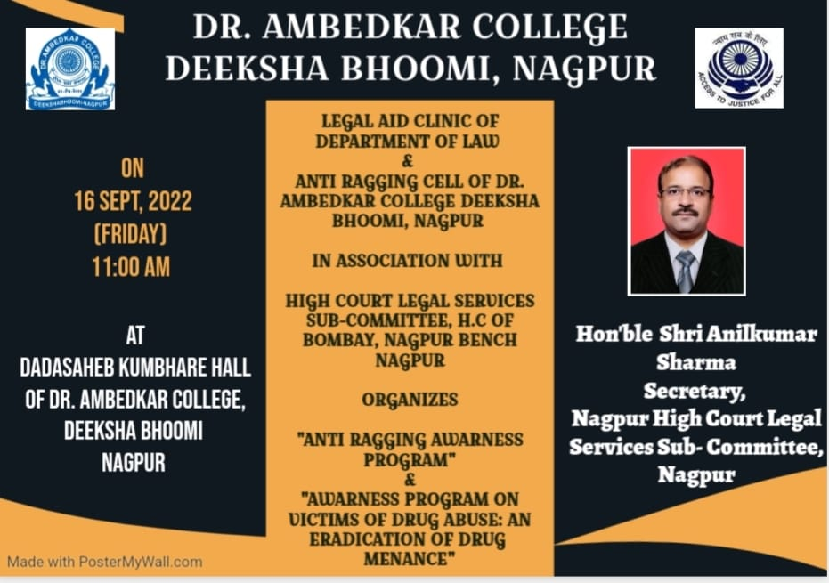

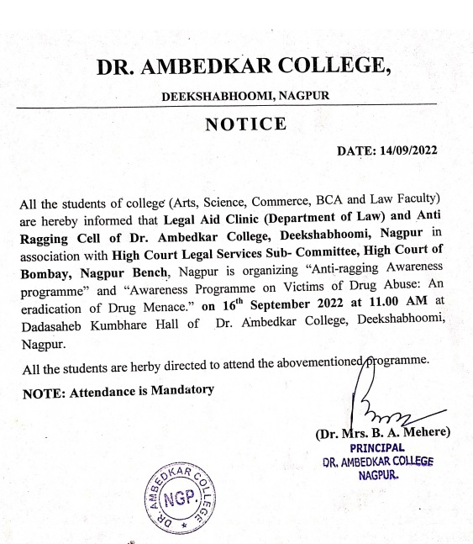

REPORT ON AWARNESS PROGRAM

The Legal Aid Clinic of the Department of Law and Anti Ragging Cell of Dr. Ambedkar College, Deeksha bhoomi Nagpur, in collaboration with Nagpur High Court Legal Services Subcommittee, Nagpur has organised an awareness Program on 7th Sept 2022 for the students of various disciplines Art, Science, Commerce, and Law.
Around 200 attendees were present in the program. Hon’ble Shri Anilkumar Sharma, District Session Judge and Secretory of Nagpur High Court Legal Services Subcommittee, Nagpur and Adv. Mrs Smita Deshpande Practicing Advocate in District Court and High Court invited as Chief guest and Guest of Honour.
The program commenced with the lamp lighting ceremony by the hand of hon’ble guests of the Programme which was followed by the welcome address by Dr. Bhoomi Mehere Principal of the college to the well acclaimed Judges, the faculty members of the departments, treasured invitees and the participants. Dr. Hema Menon gave brief information regarding department of law. Dr. Pratima Lokhande gave the overview of the Legal Aid Clinic of Department of law. Dr. Priti Singh has briefed about the Anti-Ragging cell of the College.

Adv. Smita Deshpande enlightened the audience on the topic of Anti-ragging laws. She has provided the statistical record with the courts dealing with Anti-ragging cases. Further she elaborative discussed regarding the provision of the law on Anti-Ragging. She empathetically mentioned that there is a psychological element involved in the cases of ragging.
Hon’ble Shri Anilkumar Sharma delivered the Presidential remark and shared the information regarding the provisions of anti-ragging laws. He elaborately convenience the students regarding the repercussion of the ragging in college. He further dealt with the topic on “Victims of Drug Abuse: Eradication of the Drug menace”. He has shared the statistical record of the Drug abuser and briefed regarding the various terminology of Drug abuse, drug victim and drug pedlars. He enlightened the audience with the different laws in the domain of Drug abuse.
The hon’ble guests overwhelmed by knowing that our college has no case of Ragging till present date and for that they have congratulated the college.
The Programme was conducted by Ms. Shilpa Rathod under the guidance & supervision of Dr. Pratima Lokhande, Associate Professor and Co-ordinator of Legal Aid Clinic, Department of law.
The event concluded with vote of thanks proposed by Mrs. Vaishali Sukhdeve to the jury members and also to everyone who was present to witness the event.

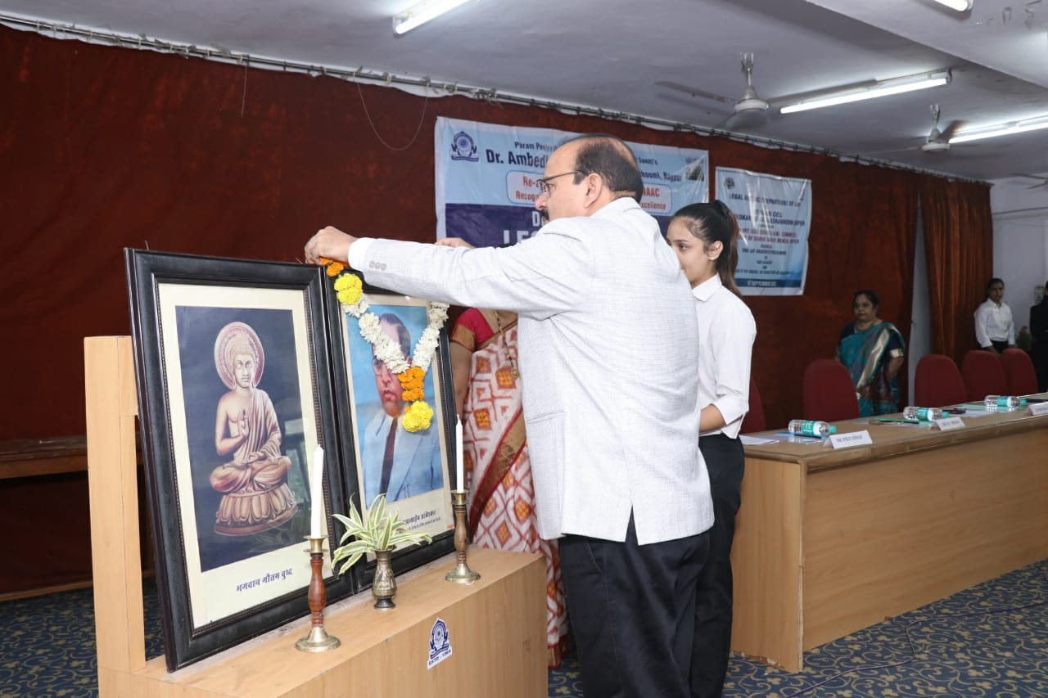
(Hon’ble Dignitaries lighting the lamp and invoking the Blessing of Tahagat Bhagwan Gautam Bhuddha and Parampoojya Dr. Babasaheb Ambedkar)

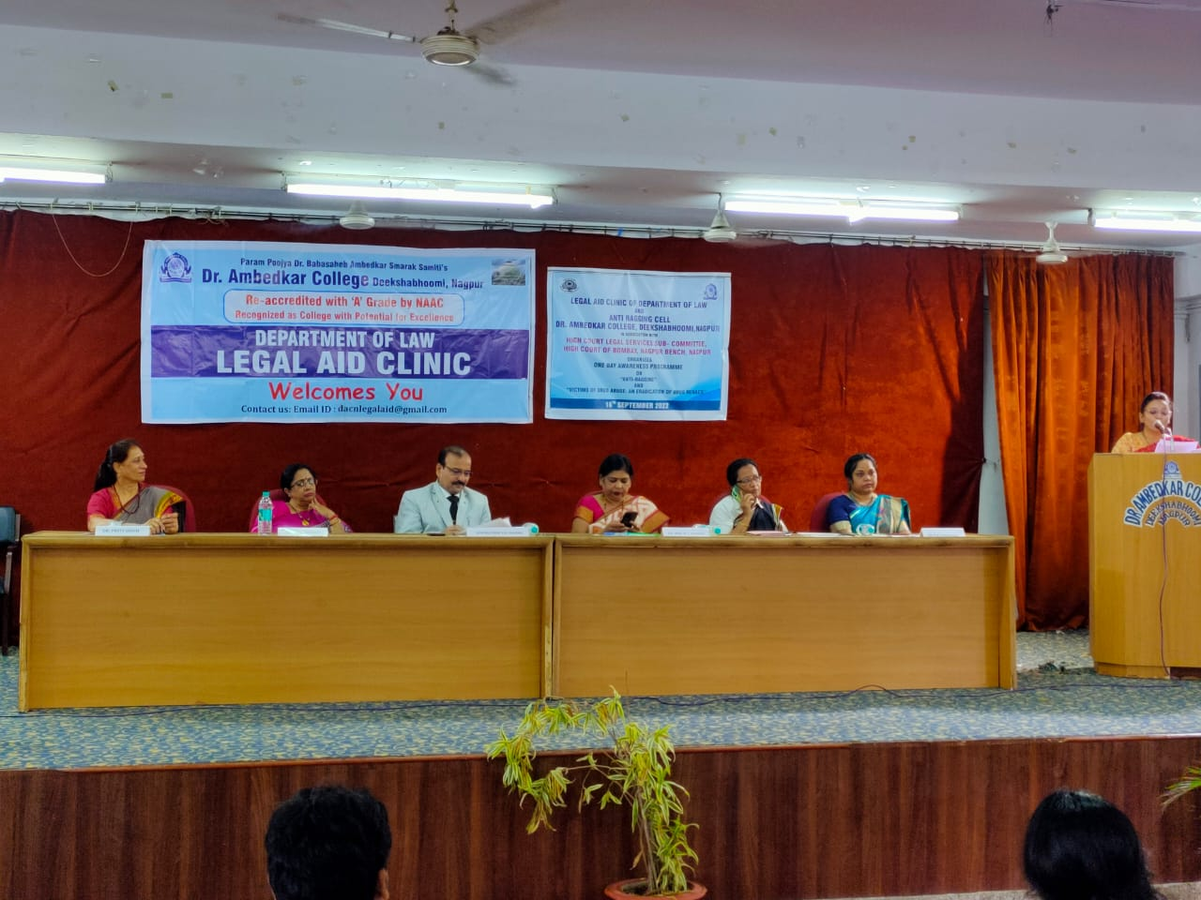
(Dignitaries on the Dias) 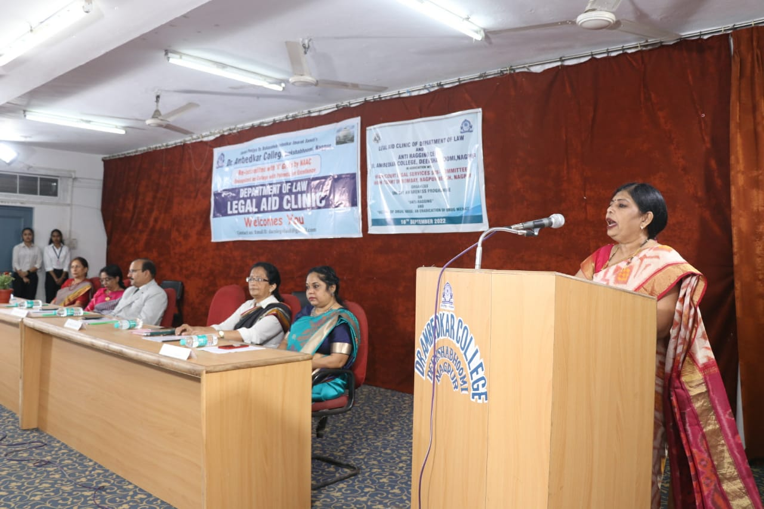
(Dr. Bhoomi Mehre, Principal of the College giving the welcome address)
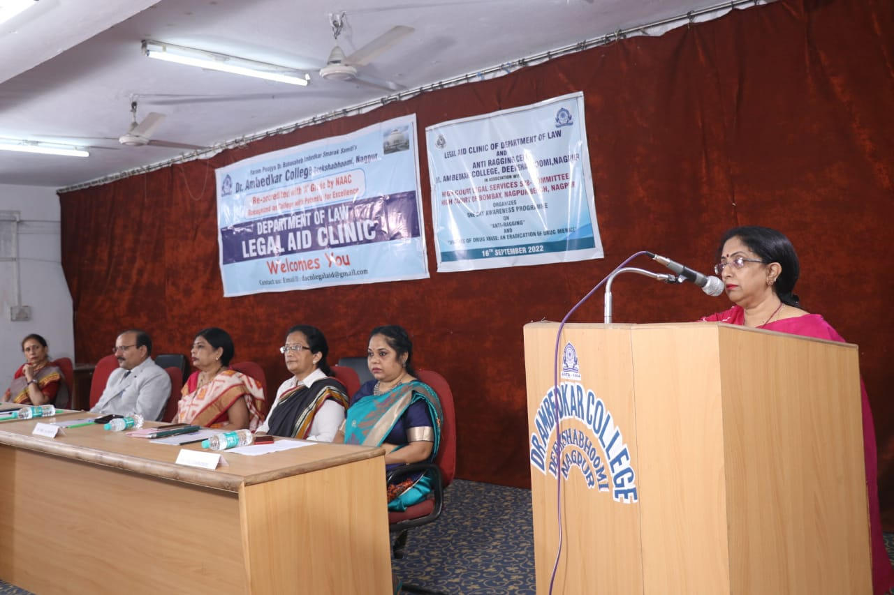
(Dr. H.V. Menon, Head Department of Law giving the brief introduction about Department of Law)

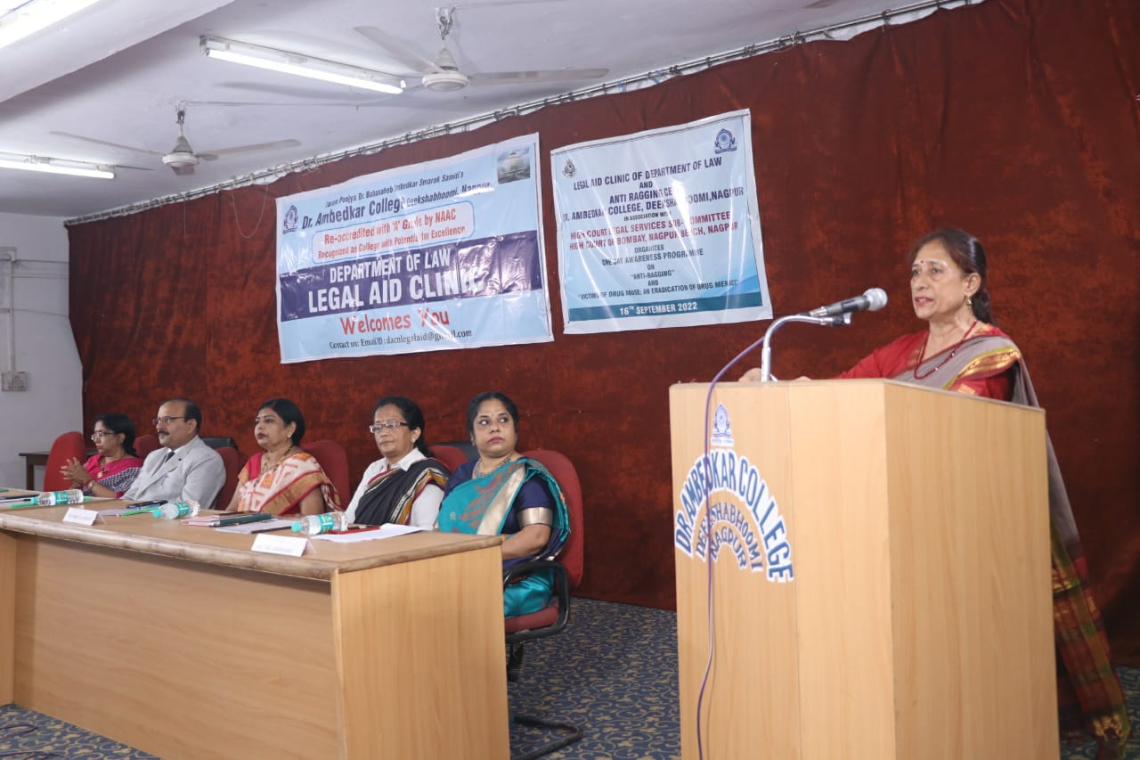
(Dr. Priti Sing Member of Anti Ragging Cell briefing about the work of Anti Ragging Cell)

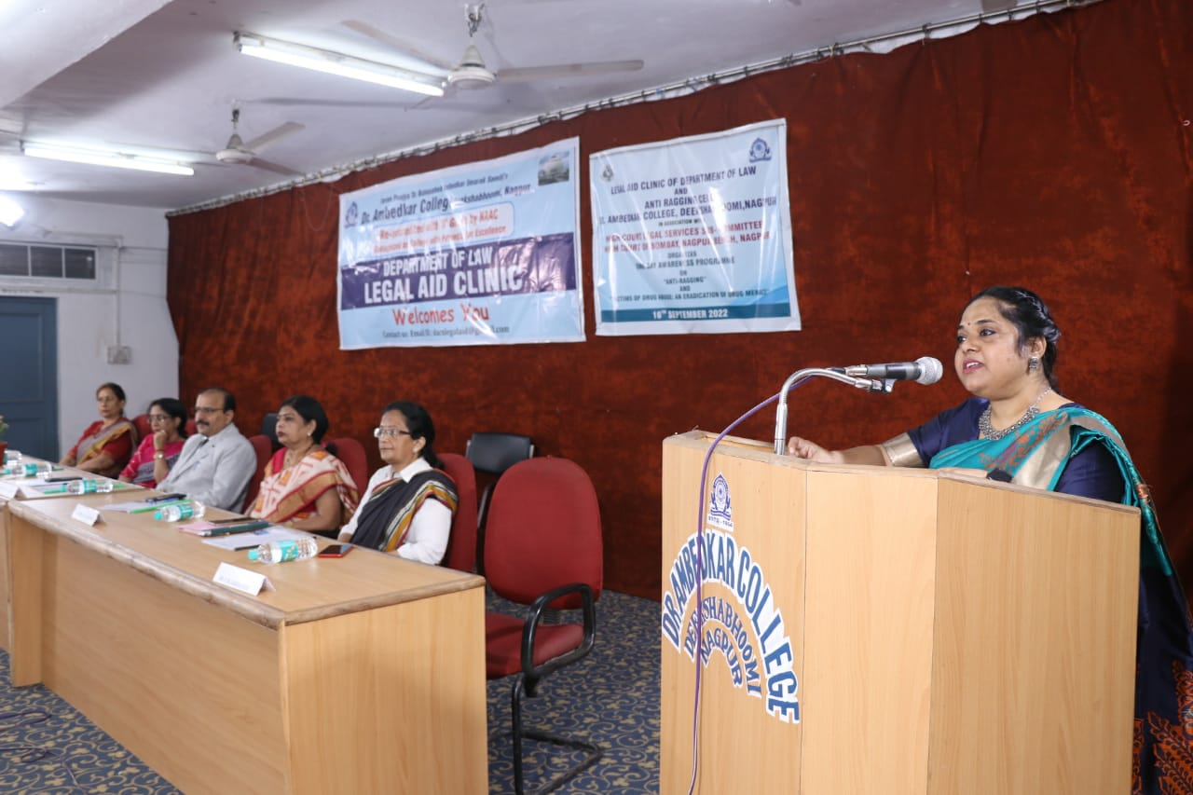
(Dr. P.R. Lokhande giving an overview of Legal Aid Clinic of Department of Law)
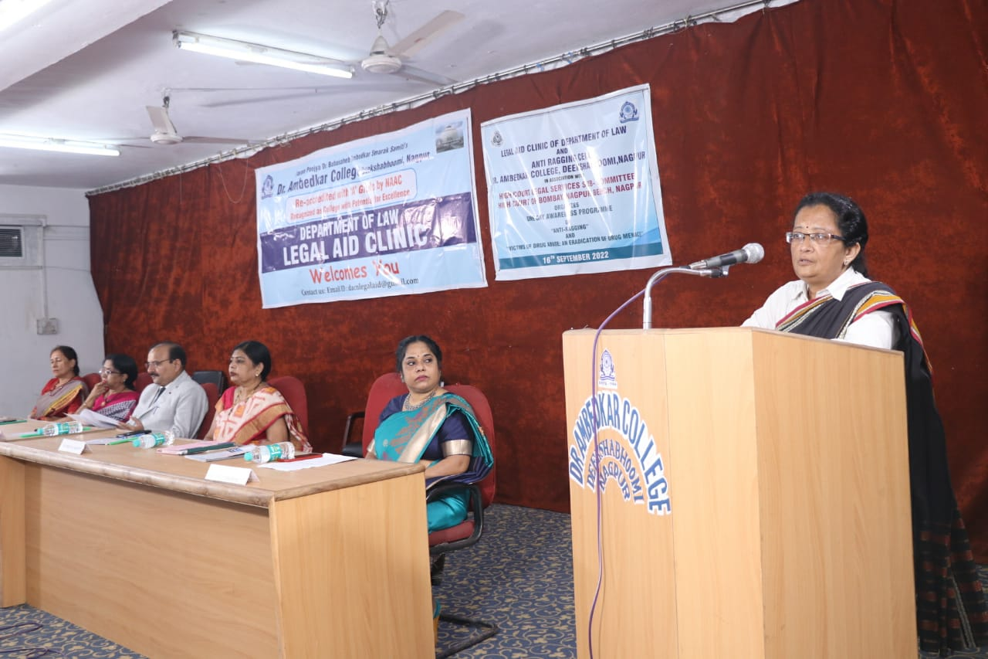
(Adv. Smita Deshpande delivering the brief provisions of the Ant-Ragging Law)

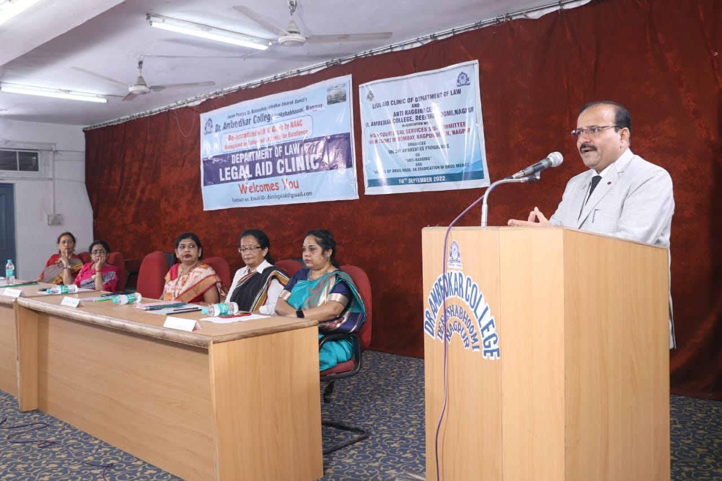
(Hon’ble Shri Anil Kumar Sharma giving the Presidential Remark)

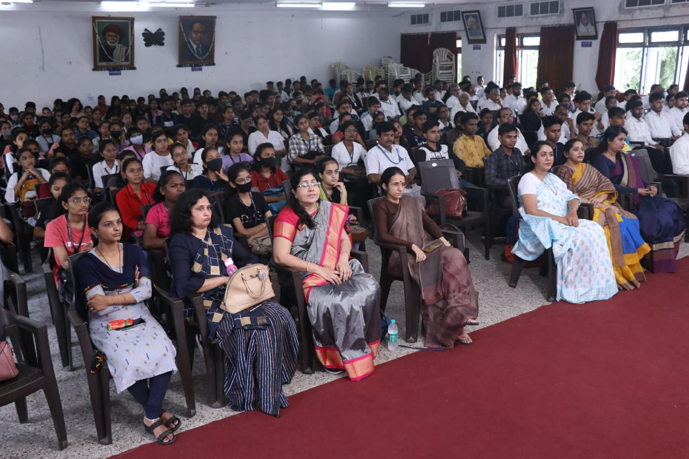
(Audience Present at the Awareness Programme)
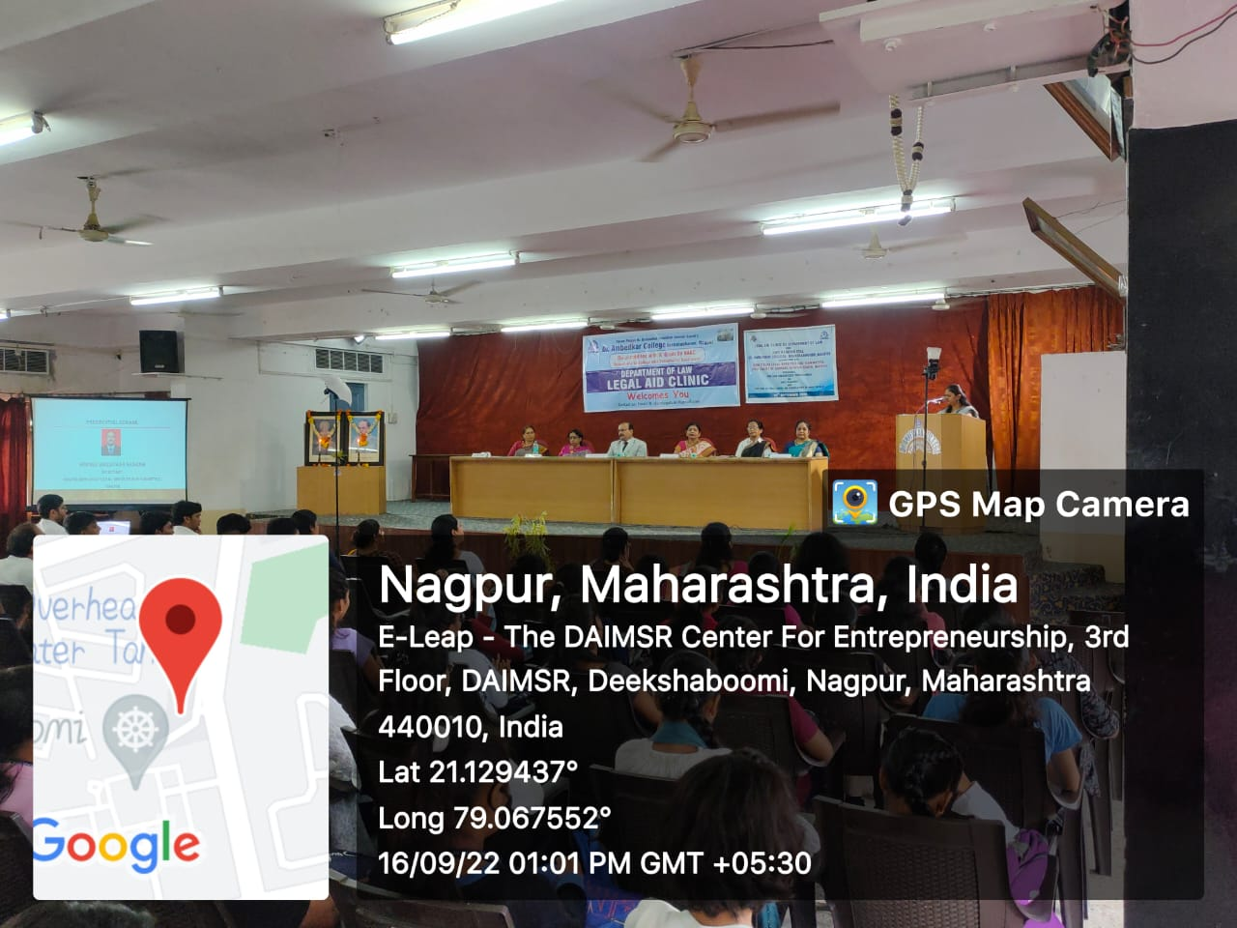
(Vote of Thanks by Mrs. Vaishali Sukhdeve, Assistant Professor Department of Law)

